**Capitulo 4.**

**Yehor Burlachenko**

|  |  |
| --- | --- |
| 654 | rw-r-xr-- |
| 766 | rwxrw-rw- |
| 777 | rwxrwxrwx |
| 520 | r-x-w---- |
| 764 | rwxrw-r-- |
| 440 | r—r------ |

1. 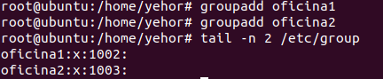
2. 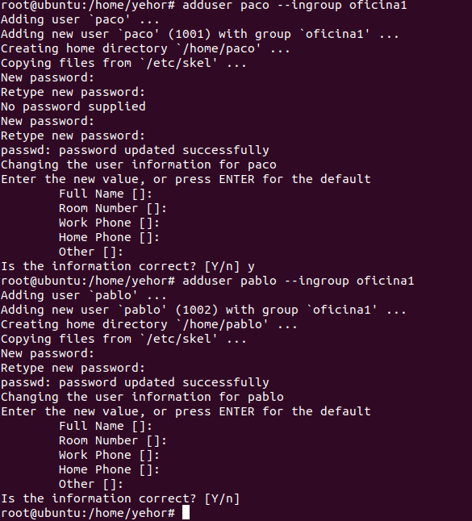
3. 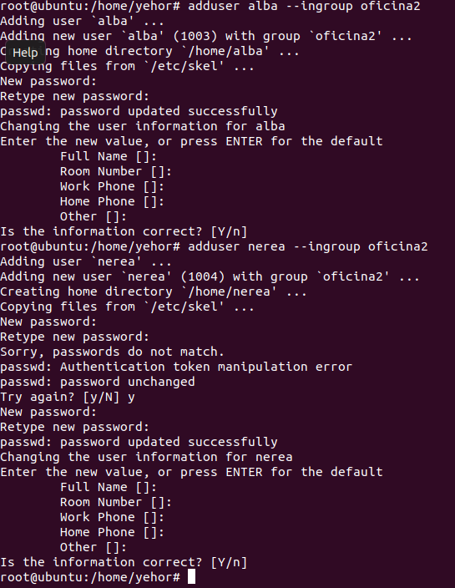
4. 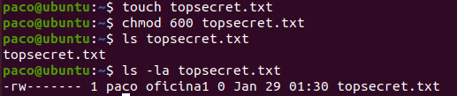
5. 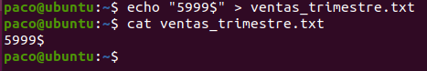  
   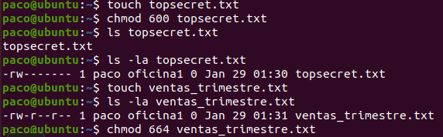
6. 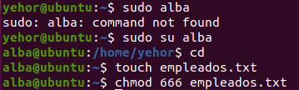
7. 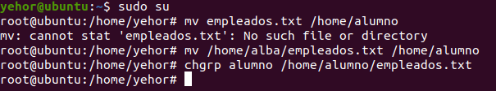
8. 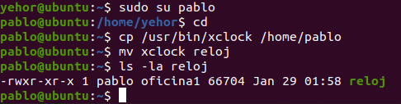
9. 
10. He creado modesto
11. He creado ficheros con touch
12. 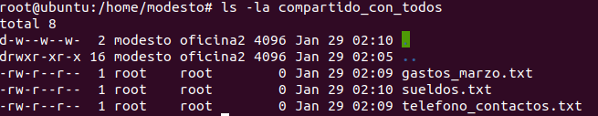
13. 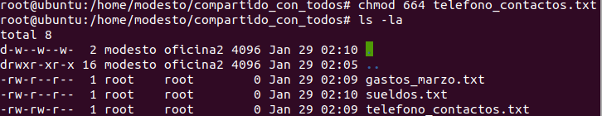
14. 
15. 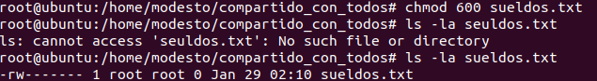
16. 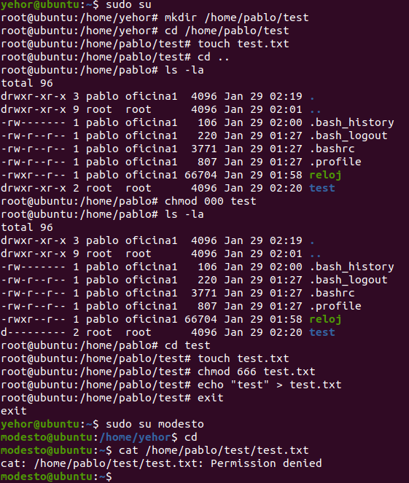

No se puede.